**HOTEL RENTAL MANAGEMENT**

**Phase 02**

**Screen Shots for the project**

**Change 1: Generic Search & combined search**

* Combined search
* Using Substring
* Case insensitive

**Example Screen 1: Combined search**

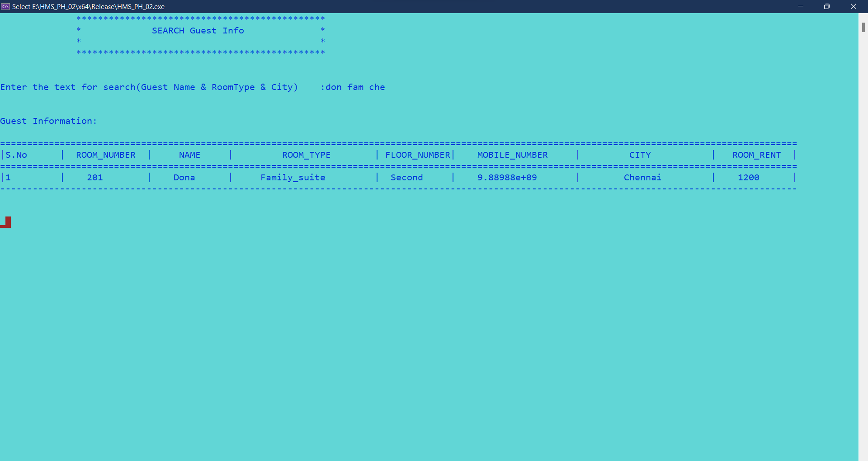

**Example Screen 2:** Using Substring & Case insensitive

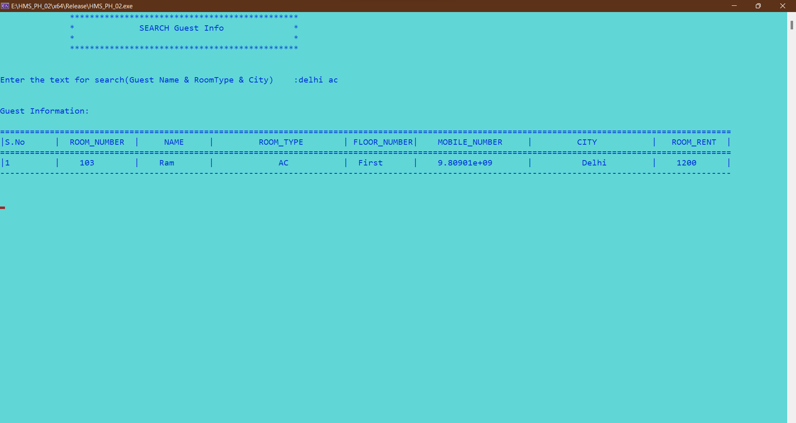

**Change 2: Automatic Check-Out**



Current date : 2022-05-17

When the System date is changed to 2022-05-20:



The Check_out_date is updated in guest_info table. And the occupied status is changed to “no”.Where it is ready for rebooking.